Agri Trends 09 March 2018

Holy Guacamole! You had me at “Avocado”.
The demand for avocado outstrips the ability of the industry to ramp up production and to meet the global demand with sufficient supply. The lack of sufficient breeding stock underpins the price levels for avocado. This trend will most likely support a growing market, which encourages growers to invest in expanding production. However, agricultural land with sufficient water that meets the requirements for high yields and delivery during the best priced marketing windows overseas is limited. Forestry land under Bloekom production and fields under sugar cane falls prey to new developments and the establishment of avocado orchards increase in both the Eastern and Western Cape provinces. South Africa grows about 17 500ha of avocados. The 2015/2016 drought negatively affected avocado yields in 2017, which resulted in lower-than-average production levels. Moreover, as 2017 was an off-season, which usually tends to deliver lower yields, production declined even further. Harvesting for the current season just started. It will be an interesting season to track and see if actual exports for 2018 meet the expectations of the avocado industry.
Contents

Maize market trends 1
Wheat market trends 3
Oilseeds market trends 5

Contact us at Absa AgriBusiness:

Conce.Moraba@absa.co.za
Karabo.Takadi@absa.co.za
Wessel.Lemmer@absa.co.za
https://www.absa.co.za/business/sector-solutions/agribusiness/trends-and-reports/

Maize market trends
International

Week-on-week yellow maize No 2 gulf price increased from US$169.16/ton to US$175.29/ton. Price support stemmed from increased US exports and continuous dry weather concerns in Argentina.

Bullish factors
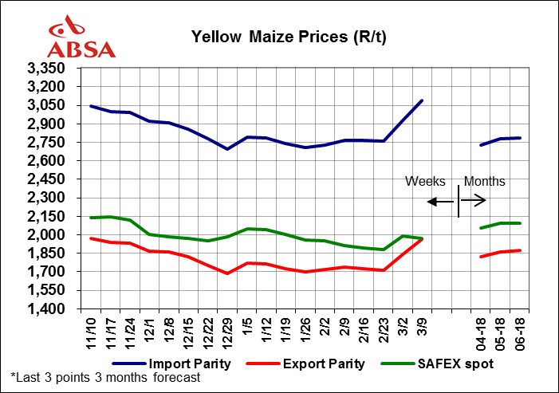
- According to the latest WASDE released by USDA. US Exports and US ethanol usage increased, supporting a reduction in carry-out stocks. The report also shows downward revisions of the Argentinian and Brazilian maize crop as weather conditions lead to crop losses. This could potentially lead to reduced global inventories. According to the USDA’s WASDE pegs global inventories for this season will be lower by 4 million tonnes to reach 199 million ton.
- It was dry in the central parts of Argentina during the week ending 9 March 2018. Maize crop remained under stress. Dry weather is set to continue in the US Plains and Argentina.

Bearish factors

- Global maize production was to a large extend left unchanged as higher production prospects in the EU and South Africa offset any reductions in Argentina, Brazil and Russia.

Domestic

The local maize market traded higher week on week by 9 March 2018. New season white maize prices for delivery in May2018 increased from R1913/ton up by 4.5% (R86/ton) to R1999/ton, Jul2018 contracts increased week-on-week by 4.6% (R91/ton) from R1958/ton to R2049/ton. Week-on-week new season yellow maize prices for delivery in May2018 increased by 5.2% (R104/ton difference) from R1990/ton to R2094/ton. Prices for delivery in Jul2018 for yellow maize were recorded at R2125/ton a 5.3% increase from R2018/ton.

Bullish factors
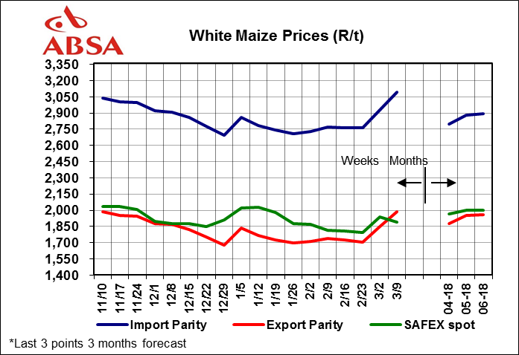
- The Rand depreciated during the week.

Bearish factors

- Weekly export figures still below expectations compared to previous years.
- Favourable weather conditions expected in the next month for the summer crop growing regions. Rainfall to improve soil moisture and assist crops.

Outlook
Local
White and yellow maize prices remain bullish irrespective of large stocks, causing lower export activity. A large maize crop is in production. Favourable weather outlook and the volatility of the Rand will remain particular focus areas, impacting the market.

International
US Exports and US ethanol usage increased, supporting a reduction in carry-out stocks. The report (USDA’s WASDE) also shows downward revisions of the Argentinian and Brazilian maize crop as weather conditions lead to crop losses. This could potentially lead to reduced global inventories. According to the USDA’s WASDE pegs global inventories for this season will be lower by 4 million tonnes to reach 199 million ton.
Yellow Maize Futures: 09 March 2018 | May-18 | Jul-18 | Sep-18 | Dec-18
CBOT ($/t) | 164.76 | 166.53 | 163.28 | 164.46
SAFEX (R/t) | 2094 | 2125 | 2168 | 2233
SAFEX (R/t)  Change week on week (w/w) | 104 | 107 | 95 | 98

Table 2: Weekly average white maize futures and estimated option prices
White Maize Futures  09 March 2018 | May-18 | Jul-18 | Sep-18 | Dec-18
SAFEX (R/t) | 1999 | 2049 | 2090 | 2159
SAFEX (R/t)  Change w/w | 86 | 91 | 83 | 85

Wheat market trends
International

The weekly average old season HRW wheat Gulf price remained at US$188.59/ton week on week, while the weekly average SRW wheat price increased from US$198.85/ton to US$207.07/ton week on week.

Bullish factors
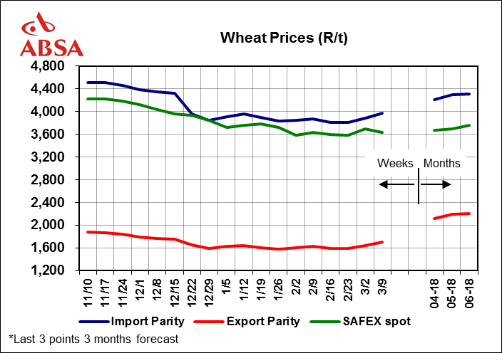
- Egypt bought 175 000 tons of Russian wheat.
- Russian exports were raised by another 1.5 million ton in the latest USDA WASDE outlook.

Bearish factors

- The USDA raised its wheat outlook for world stocks for 2017/18 to a new record of 269 million ton, citing ample global stocks. Supplies are set to increase by 25 million ton, because of sluggish US export demand for HRW (15 million ton reduction in exports) and HSW (10 million ton reduction in exports). Lower export demand is driven by price competitiveness issues with other players in the global market.
- High global supplies offsetting the price support from the drought in some parts of the US Plains wheat belt. Also the crops conditions are stabilizing in the US Plains.

Domestic

On 9th March 2018, wheat prices for delivery in May2018 increased marginally by 0.8% (R28/ton) from R3674/ton to R3702/ton. Jul2018 prices increased marginally by 0.8% (R30/ton) from R3725/ton to R3755/ton, week on week.

Bullish factors

- Local prices traded positively following higher international prices, supported by unfavourable weather conditions in the US.

Bearish factors

- The lower tariff of R394.90/ton still pending publication will have a negative effect on the producers during their optimal planting time.
- The Rand slightly weakened during this week after rallying the previous weeks.

Outlook

Local
The stronger Rand will enable more wheat imports to supplement the local needs after SA’s very poor wheat season. Weather outlook for the next week shows possible rainfall for the Western Cape.

International
The USDA raised its wheat outlook for world stocks for 2017/18 to a new record of 269 million ton, citing ample global stocks. High global supplies offsetting the price support from the drought in some parts of the US Plains wheat belt.

Wheat Futures  09 March 2018 | May-18 | Jul-18 | Sep-18 | Dec-18
CME ($/t) | 185.74 | 191.80 | 199.15 | 204.3868313
SAFEX (R/t) | 3702 | 3755 | 3731 | 3712
SAFEX (R/t)  Change w/w | 28 | 30 | 31 | 35

Oilseeds market trends
International

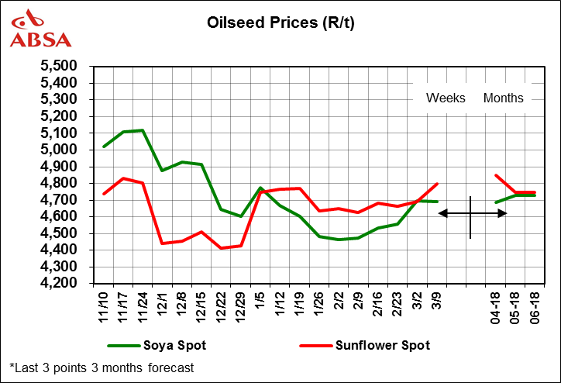
The weekly average USA soybean price increased week-on-week from US$404.54/ton to US$405.83/ton.US soya oil prices marginally declined from US$32.19/ton to US$31.99/ton and soymeal prices traded higher from US$355.68/ton to US$362.08/ton.

The ongoing concern about soybean crop losses due to the Argentinian drought could not offset declines in soybean prices this week.

Bullish factors

- The Argentine soybean crop is estimated at 42 million ton, a 9-year low. Further downward revisions are expected. It is possible Argentinian production could end up lower than 40 million ton. Brazil’s production is expected to ally some of the shortage, but production in parts of Paraguay, Bolivia and Uruguay is also significantly down.
- Soymeal prices ballooned on the global market since January (increasing by US$100/ 30%).
- Olive oil supply shortage in EU, keeping prices high in Spain since January.

Bearish factors

- Vegetable oil prices were not as responsive to the Argentinian drought. Palm oil supplies on the global market remain large and offset any losses in soy oil.
- Another very large Brazilian soybean crop is in production.
- US carry out was raised by 25 million bushels (680 400 tonnes), citing slower exports in the latest WASDE USDA report.
- Russia sunflower seed in Jan/Feb 2018 exceeded expectations. Production estimate for the Russian crop rose to 10.8 million ton.

Domestic

On March 9th , new season sunflower seed prices (May2018) increased marginally week on week by 0.1% (R4/ton) from R4743/ton to R4747/ton while soybean (May2018) prices decreased by 2% (R97/ton) from R 4826/ton to R4729/ton. The ongoing concern about soybean crop losses due to the Argentinian drought could not offset declines in soybean prices this week. Vegetable oils prices were lower, abundant world palm oil supplies weighed down the market.

Bullish factors

- Sunflower seed planting was below expectations due to lower rainfall received in January 2018.
- Due to production failures in Argentina, soymeal prices still trading fairly high. South Africa is a net importer of soymeal/cake.

Bearish factors

- Improving weather conditions are raising the soybean crop production prospects.
- Due to production failures in Argentina, soymeal prices still trading fairly high. South Africa is a net importer of soymeal/cake.
- Anticipation for South Africa to produce another bumper crop in 2018 of 1.3 million tons, 4.46% higher than the previous season’s harvest.

Outlook
Local
Deteriorating soybean production prospects in South America expected to support higher domestic soybean prices. Rand volatility will also be a key factor to monitor.

International
Global palm oil and soya oil expected to trade sideways or slightly higher in the next few weeks.
Due to weather constraints in South America, deteriorating S. American soybean supplies have caused the global need for US soybeans. Therefore US is expected to increase its soybean planting this spring. The increased dependence on US soybeans for the rest of 2018 means that any adverse weather /production in the US Midwest could bring about bullish fundamentals to the global soybean market from July 2018.

Oilseeds Futures  09 March 2018 | May-18 | Jul-18 | Sep-18 | Dec-18
CBOT Soybeans (US$/t)** | 378.64 | 379.20 | 370.47 | 358.99
CBOT Soy oil (US c/lb) | 33.13 | 33.03 | 33.63 | 33.53
CBOT Soy cake meal (US$/t)* | 385.60 | 385.27 | 380.11 | 372.64
SAFEX Soybean seed (R/t) | 4729 | 4833 | 4936 | 5032
SAFEX Soybean seed (R/t) change w/w | -97 | -90 | -63 | -63
SAFEX Sunflower seed (R/t) | 4747 | 4800 | 4938 | 5040
SAFEX Sunflower seed (R/t) change w/w | 4 | 45 | 64 | 0
*short ton
** Dec 2018 = Jan 2019

Vegetables market trends
Generally the vegetables’ deliveries were low for the week ending 09 March 2018.

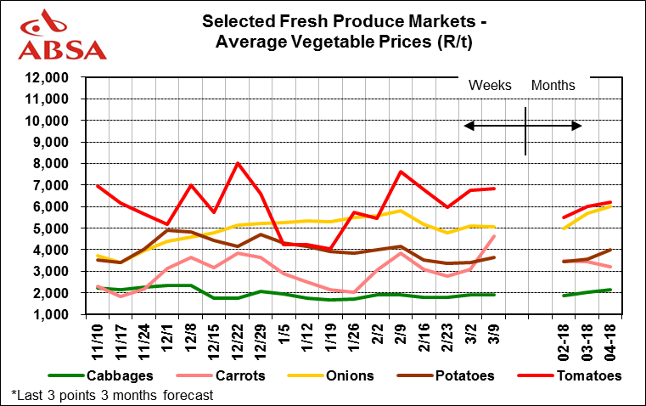
Potato prices higher week on week
Lower volumes available (33% decline week on week), at the Top 5 FPM lead to a 7% increase in the potato market. Prices are currently trading at R25 per 7kg bag compared to R23.8/bag last week. Prices expected to remain trading at R25/bag-R27/bag for the next 2 weeks.

Pepper prices drop 24% w/w
Poorer quality produce delivered, and marginal decline in volumes due to lower demand have steered this trend for the week of February 2018 and 1st 2 weeks of March 2018.

Carrots
Carrots were the biggest gainer of the Top 5 vegetables in the Top 5 FPM for the week ending 09 March 2018. The 50% price gain stemmed from a 39% decline in volumes delivered.

Week ending  09 March 2018 | Difference in weekly prices (R/t) | This week’s  Average  Price (R/t) | Previous week’s  Average  Price (R/t) | Difference in weekly volumes | This week’s  Total  Volumes (t) | Previous week’s  Total  Volumes (t)
Cabbages | 2% | 1926 | 1896 | -25% | 1562 | 2078
Carrots | 50% | 4610 | 3076 | -39% | 2030 | 3348
Onions | -1% | 5062 | 5088 | -35% | 5782 | 8832
Potatoes | 7% | 3642 | 3416 | -33% | 13945 | 20693
Tomatoes | 1% | 6839 | 6748 | -25% | 3901 | 5181
Peppers | -24% | 5873 | 7776 | -3% | 1060 | 1094
Disclaimer: Although everything has been done to ensure the accuracy of the information, Absa Bank takes no responsibility for actions or losses that might occur due to the use of this information.

Disclaimer: Although everything has been done to ensure the accuracy of the information, Absa Bank takes no responsibility for actions or losses that might occur due to the use of this information.

